**Divya Sree.T** 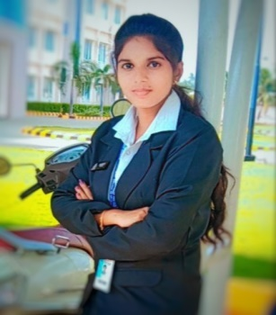

**B.Sc Information Technology**

**Career Objective:**

I would like to secure a position in a company where I can use my skills and abilities to make a contribution to the organization.

**Academic Profile:**

|  |  |  |  |
| --- | --- | --- | --- |
| **Course** | **Name of institution** | **Percentage**  **/CGPA** | **Course Duration** |
| B.sc(IT) | A.V.P College of Arts and Science | 9.2 | 2021-2024 |
| HSC | Murugu Matric Hr. sec. school | 92% | 2020-2021 |
| SSLC | M.N.Chickanna Chettiyar Matriculation School | 82.6% | 2018-2019 |

**Skills:**

Technical Skills:

* **Programming Language** : C Programming, Java
* **RDBMS and Query Language**: MySQL,SQL
* **Web Technologies and Microsoft products**: HTML, CSS, Word, PowerPoint and Excel

Soft Skills: Computer Literacy, Problem Solving, Strong Communication.

**Area of Interest:**

* Programming
* Database Management & Business Accounting.

**Project Details:**

Web Portal for Online Car Sale

Designed one-stop web portal to view the specifications of cars and to facilitate customers with services such as sales and service.

Enhancing Lifi Technology, Soil moisturizing sensor and Automatic hydro soil irrigation

Imparted Arduino programming to design these projects under the area of sustainable environment and honored with 2nd prize for sophisticated Idea.

**Certifications:**

* Completed certification on **My SQL Basics & C Programming** from Great Learning and Solo Learn platform.
* Completed TCS ion Career Edge Young Professional Certification.

**Academic Achievements:**

* Secured 2nd Rank on subsequent semester during the academic year of 2021-23.
* Honored as star of the department as well as president for best academic performance and effective Leadership & Management.

**Workshops/ paper presentation attended:**

* National and International Level Seminar workshop on **IOT Based Ardubotics Robotics workshop and Design Thinking on Innovation & Life skills**.
* Attended Workshop on **soft skills** conducted by Daffodils Literary.
* Presented Paper on **5G Technology** and awarded 1st prize for best content.

**Personal information:**

**Resident Address :** Venkateswara Garden, Pooluvapatti

**Mobile Number :** +91 6374547732

**Email Address :** sreehari0411970@gmail.com

**Declaration:**

I hereby declare that all the details provided above are true to the best of my knowledge.

**Place:** Tirupur (**Divya Sree**)